Julia Vineyard

Software Setup Lab Report

1. OneDrive

1. Azure Virtual Desktop

1. RStudio session with hello_world

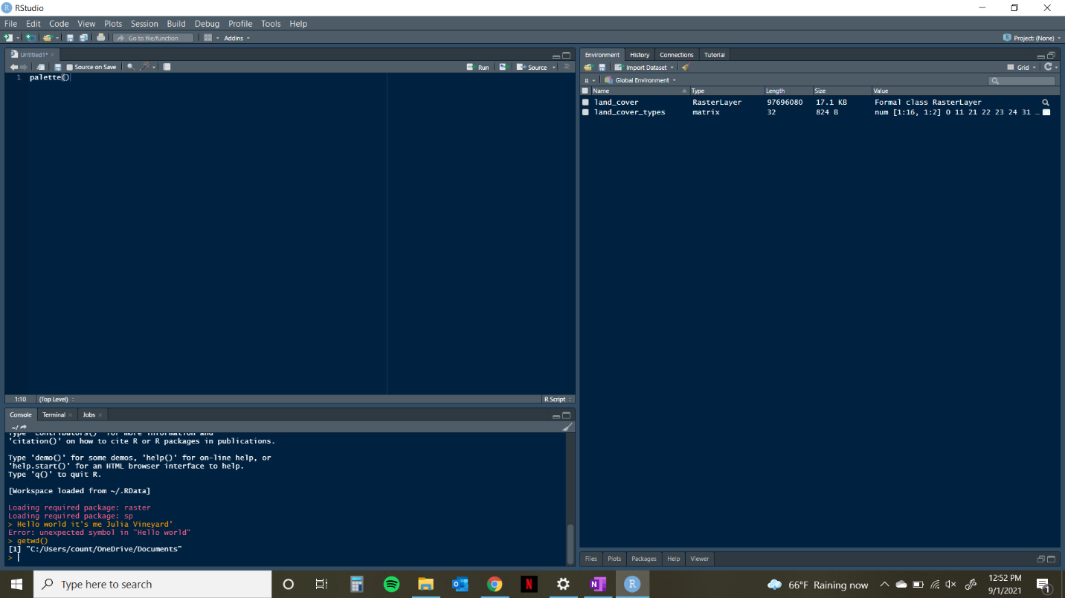

1. Course Folder

1. RProject with correct project options

